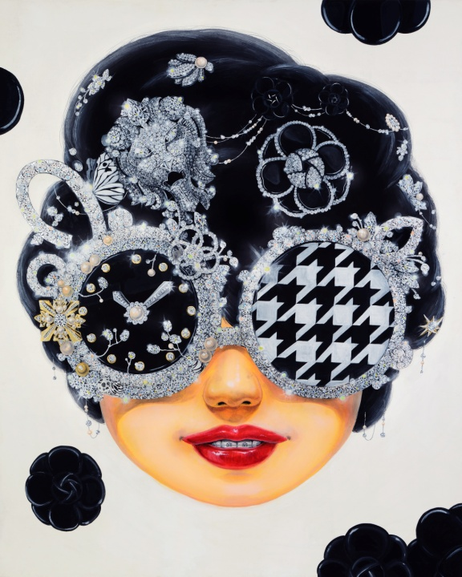
Sealed smile, Color on Korean paper. 163x130cm, 2015

KIM Jihee
Born in 1983
lives and works in Seoul, Korea

Education
2003-2007 B.A. in Oriental Painting from Ewha Womans University
2007-2009 M.A. in Oriental Painting from Graduate School of Ewha Womans University

Selected Solo Exhibitions
2016 Kim Jihee Invitation Exhibition, PYO Gallery
2014 Kim JIHee Invitation Exhibition “Lucky Strike”, Mercedes-Benz auto gallery
2013 Special Invitation Exhibition of Chungjark Gallery- Kim JIHee Invitation Exhibition “Virtual Camouflage” , Chungjark Gallery
2012 SOAF Special Exhibition "MISSHA WITH KIM JUHEE", COEX
2011 Commemorative Exhibition for Chungjark Award- Kim JIHee Invitation Exhibition "Collection of Desire" , Chungjark Gallery
And etc.
Selected Group Exhibitions
2015
KIAF [COEX]
Asia hotel art fair [Conrad hotel]
Affordable Art Fair [DDP]
Living with pop [YeulmaruMuseum]
Chennai Biennale [Chennai, India]
Diary of family [Yangpyeong Art Museum]
Young Art Taipei [Sheraton hotel, Taipei]
bling! bling! [Art Factory Gallery]
Asia Contemporary art show [Conrad hotel, Hong Kong ]
2014
Kiaf[Coex]
SOAF [Coex]
Adore me [Gallery We]
Double – Duo Exhibition of Kim Jihee, Chalse Jang [Gallery Lina]
Singapore Bank Art fair 2014 [Pan pacific hotel Singapore]
PINK ART Exhibition [Ara Art Center]
Asia Contemporary Art Show [Conrad Hotel, Hong Kong]
Daegu Art Fair [Daegu Exco]
Gwangju International Art Fair [KDJ Convention Center]
Wart Show [Lotte hotel]
Asia Hotel Art Fair [Lotte hoel]
Adore me [Gallery We]
Heyri Art road 77 [Gallery Rio]
Osaka Hotel Art Fair [Granvia Hotel, Osaka]
And etc.

Award
2011 Cheongjak Fine Art Award
2007 Art Award from Japanese Exhibition and many others

Glamorous glasses, flowers and butterflies are the symbolic imageries of Kim, Jihee’s artwork along with mysterious smile and peeping braces. The artist consciously express her modern theme by depicting front faces without bodies made to look man-made on Korean traditional paper. The glamorous and decorative features are enough to attract viewers and so do the braces hidden behind the smile make them unrest with curiosity. Her works begin from the chaos between acquired desire and natural desire. The figure smiling and wearing glasses covered with huge and sparkling ornaments that hide the truth-telling eyes portray the acquired desire. The desire to live bigger and glorious life is revealed through the highly decorated glasses.

