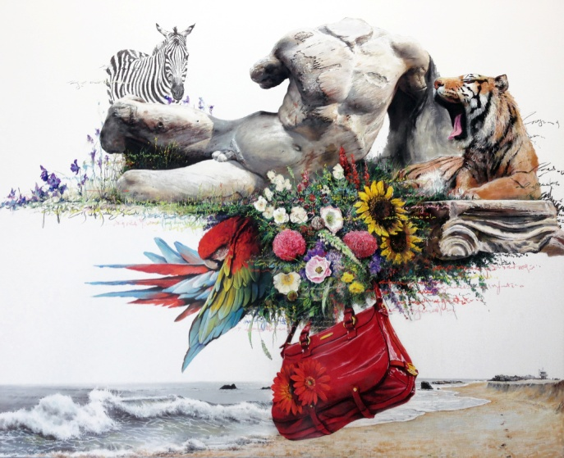
Instant Landscape-Androgynyous#3, Charcoal and pastel on canvas, 162.2x130.3cm, 2014

KIM Nampyo
Born in 1970, Seoul, Korea
Works and lives in Seoul

Education
2006 M.F.A., Painting, Seoul National University, Seoul
1998 B.F.A., Painting, Seoul National University, Seoul

Solo Exhibitions
2015 Fingertip-scape, a route, Seoul
2014 Phantasmagoria – The route of sense, Insa artcenter, Seoul
2013 Instant Landscape – Traveler, Seoul Auction, Seoul
2010 My Art is My World _ Encounter of the Two Worlds, Kim Nam-Pyo & Ji Yong-Ho, Gana Art
Center, Seoul
2009 Instant Landscape, Gana Art NY, New York
Instant Landscape, Goozee Gallery, Daegu
Instant Landscape, Canvas International Art, Amsterdam
2008 Instant Landscape, Gallery IHN, Seoul
2007 Instant Landscape, Gallery HYUNDAI-Window Gallery, Seoul
Instant Landscape, Canvas International Art, Amsterdam
2005 Stopping for a While, Vinyl Gallery, Seoul
1999 1st Solo Exhibition, Woonggeon Gallery, Seoul

Selected Group Exhibitions
2016 ‘AndrogynyⅢ’, Atelier Aki, Seoul
Unfamiliar Feeling, Naesorak Mountain Art Museum, Kangwon-do
Art & Flower collaboration, NAM.K art gallery, Seoul
Breath of Forest, Incheon Shinsegae Gallery, Incheon
Prologue, 640art tower gallery, Seoul
‘Androgyny’, Atelier Aki, Seoul
2015 ‘Dowon’, Atelier Aki, Seoul
‘Hositamtam’, Korea university museum, Seoul
Paris-Daily temptations, seoul art center, Seoul
OCEANUS K-ART oceanus arthall, Pusan
2014 Material Magic, ilwoospace, Seoul
2013 Residing in private place, Atelier Aki, Seoul
journey in the book, gallery PURPLE, Gyeonggi
Residing in private places, Atelier Aki, Seoul
Primavera, Amway Museum, Gyeonggi
Contemporary Age: 30 years with artists, Gana Art Center, Seoul
Art by MKZ, Beyond Museum, Seoul
Cool Running, Lotte gallery, Seoul
And etc.

Collections
Seoul Museum of Art, Seoul
National Museum of Modern and Contemporary Art, Art Bank, Seoul

Awards
Arts Council Foundation Award
Gold Medal, National University Art Exhibition
Gold Medal, Creative Art Association

Artist Statement
“My work possesses impromptu and coincidental forces. From the expression of the canvas to the decision of the specific image, I represent on to the canvas, the results of my instant absorption and imagination (..) To me, nature and its landscapes are a figure of constancy, relative to the instant and irregular fragments of uneasiness of this era. But on the other hand, nature is fragile and weak, always the loser in the logics of power. Because of this reason, the animals appearing on the canvas sometimes seem to be so peaceful sometimes as if they are on guard.”

