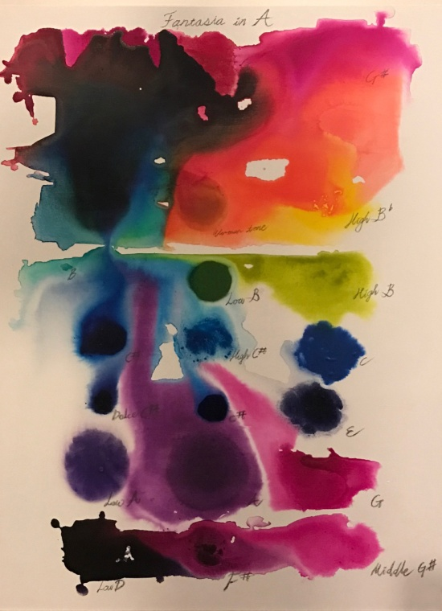
Fantasia in A, 30 x 40 inch (76 x 101cm), Acrylic on Canvas, 2016
LEE Jaewook
Born in 1984, Korea

Education
2015 MFA Fine Art, Carnegie Mellon University, Pittsburgh
2014 MFA Art Practice, School of Visual Arts, New York
2006 BFA from Korea National University of Arts, Seoul

Solo Exhibitions
2016 Treatise on Rhythm, Color, and Birdsong, Space O’NewWall, Seoul
2015 Object Theory, O’NewWall E’juheon, Seoul
2015 Jaewook Lee solo show, Sindoh Art Space, Seoul
2011 Big Seoul (1971), PYO gallery south, Seoul 2009 Beautiful, Project space Kunst-Doc, Seoul
2009 Golden Bomb at KIAF 09 (commissioned solo installation), Korea International Art Fair, COEX, Seoul 2007 At the Highest Point in Asia, Art space HUE, Seoul
2005 The 5th Art Wall Project, Coreana Museum, Seoul

Two-person Exhibitions
2014 When All Things Evaporate We’ll Talk About Minerals (a collaboration with Simone Cou to), Pioneer Works, Brooklyn
2012 Building/Unbuilding (Charlie Hahn and Jaewook Lee), Space 53, Seoul
2009 Re-New, Gallery Art Link (Jaewook Lee and Bark Byung Il), Seoul
2008 A Look at the City – Disquieting Truths (Jaewook Lee and Hongsik Kim), SEO Gallery, Seoul
2005 SEO 2nd Wall-Painting Project (Jaewook Lee and Jin Joon Lee), SEO gallery, Seoul

Selected Group Exhibitions and Screenings
2016
Dove Audio&Video Festival, Slow Slow Quick Quick, Seoul
Asia Kula Kula-ring, Asia Culture Center, Gwangju
London Biennale Manila Pollination, 98B COLLABoratory, First United Building, Escolta Manila, Philippines Transart Triennale BERLIN PROGRAM 2016, Uferstudios, Badstrasse 41A (gate 1), Berlin
Station Moves, ZAHA Museum, Seoul

2015
Neue Empiriker-We Shape Clay into A Pot, Frappant e.V., Hamburg
Neue Empiriker-Your Memories Picture History II, Alternative Art Space IPO, Seoul
NURTUREart Benefit, Boiler Pierogi Gallery, Brooklyn
Singapore Open Media Art Festival (a collaboration with Ali Van), Gillman Barracks indoor & outdoor space, Singapore
(Six unknowable symbols), Miller gallery, Carnegie Mellon University, Pittsburgh
Time, Watered by Memories of the Other (curated by Yongdo Jeong), Gallery Kunst-Doc, Seoul
Your Memories Picture History (curated by Yongdo Jeong), ZAHA Museum, Seoul
And etc.

Work
Tschoon Su Kim's work is rooted in a tradition of gestural abstraction and the use of the color blue. Since 1990 Kim has been painting almost exclusively in blue. He researches the color's different shades in work series called Ultramarine, Blanco y Azul or Weiss und Blau and herein wakens up associations of water, heaven or trees without really having painted them.

<LIGHTNESS AND FLIGHT>
Jean-Louis Poitevin

“(…)The challenge of the approach of Jaewook Lee is simple: go in, to see what happens between sound and color, as between one discipline and another, as between matter and spirit as are de facto caught in a complex set of relationships that we like just to deny or explain by quibbles theologically uncertain trend.(…) This is what Lee Jaewook by sliding between these two complementary versions of the world, too quickly appointed order and chaos, fluid forms, flows materialized lightened sound intentions and issued intellectual experiences of psychic heavy duty tell the truth or duty to an object or having to dwell on its own heaviness.”

