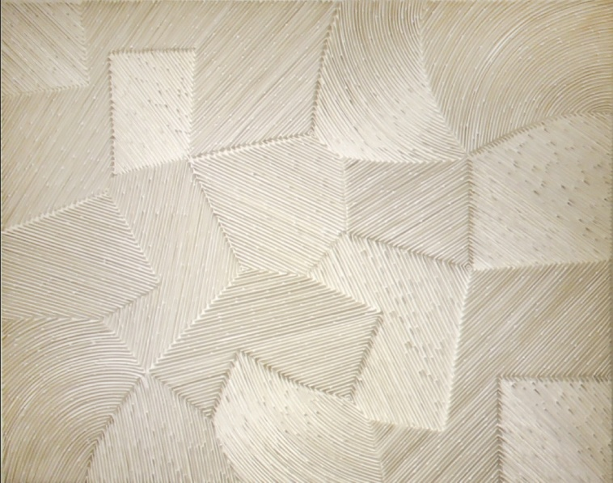
Existence-Wave,09,W.G.B, 116.8x91, Silicone on Canvas, 2009

OH Yiryang
Born in 1964

Education
1991 M.F.A. Graduated from the Printmaking Dept. Tama Art University, Tokyo Japan
1986 B.F.A. Graduated from the Painting Dept. College of Fine Arts, Chosun University Korea

Selected Solo Exhibitions
2015 S+ gallery, Busan
2009 PYO Gallery, Seoul
2008 UM Gallery, Seoul
2006 Amano Gallery, Osaka.
2005 Gallery ARTSIDE, Seoul
2003 Gallerie Bhak, Seoul
2001 Posco Art Museum, Seoul
2000 Amano Gallery, Osaka
Gallery MA, Fukuoka
1999 Kumho Museum of Art, Seoul
1998 Gallery Art Alpha, Tokyo
1988 Nisshin Gallery, Tokyo
And etc.
Selected Group Exhibitions
2009 Apicture of new flowers and birds,in.ter alia Art Company,Seoul
Gallery DIO an opening commemoration exhibition, Gallery DIO,Gangwondo
Seoul Art Fair,BEXCO. Busan
2008 ART Singapore, Suntec Singapore Level 4
Seoul International Print, Photo Art fair, Seoul Art Center
PRINT,IN THE SPACE, Cyan Museum Of Art, Gyeongsanguk-Do,Korea
Seoul Art Fair,BEXCO. Busan
Aesthetics of boredom-Monochrome, Gwangju Museum of Art
Korean Contemporary Art Festival, Seoul Art Center
Seoul Open Art Fair 2008, COEX Indian Hall
Reproduction of The Times Print Aesthetics-Edition, Gyeongnam Art Museum
Flow Exhibition of the Korea modern print,JeonBuk Art Museum
And etc.

Selected Awards
1999 Graphic Art Biennale Dry Point, UZICE, Yugoslavia. Bronze Point Prize
1998 AGART World Print Festival'98, Ljubljana, Slovenia. Grand Prix
1998 Biennial IBIZA Grafic, Contemporary Art Museum Ibiza, Spain. Third Prize
1998 Biennial of Graphic Art BEOGRAD'98, Yugoslavia. Special Mention Prize
1997 Portland lnternational Print Exhibition, Portland Art Museum, Purchase Prize
1996 The Korea Young Artist Biennial, Daegu Art & Culture Center. Grand Prix
1994 International Miniature Print Exhibition, Space Gallery, Seoul. Selected Prize
1992 Norwegian lnternational Print Triennale, Norway. Honorable Mention Prize
And etc.

Selected Collections
Portland Art Museum, U.S.A
Ibiza Contemporary Art Museum, Spain
National Museum of Art, Seoul
Seoul Museum of Art, Seoul
Busan Museum of Art, Korea
Taejon Museum of Art, Korea
Gwangju Museum of Art, Korea
And etc.

From 1988 when he studied in Tokyo, he has been infatuated with the problem of existence. Therefore, he has created works with different thickness of silicon to maximize its own feeling ‘surge’, which is part of components of the present. In addition, he excludes shape and colors which make eyes confusing, and puts connection of simple lines or ‘surge’ of overlapped lines in the works using unique material ‘silicon’.

